Sprite SevenUp

Main ship

Brute force

disable mask
Mask – uncheck mask

File – Output options

GFX + Attr

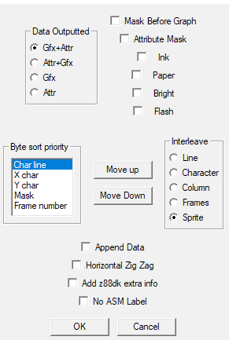
not enough data

